# **rmdir Command**

**rmdir Command:**

1. rmdir-Deletes a Folder.

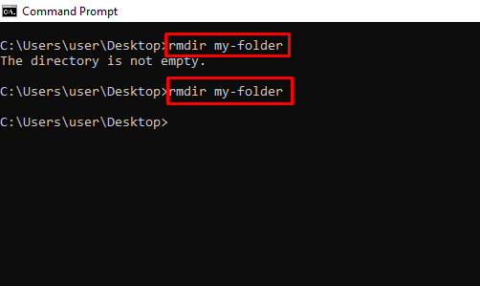

1. rmdir “foldername” /S /Q-Deletes a Folder with subfolder and silently.